Software

Requirements Specification

For

4 x Gen4L-block Tester software

Version 02

|  |  |  |
| --- | --- | --- |
|  | **Name** | **Date** |
| Written by: | Meir Bar Nathan |  |
| Approved by: |  |  |
| Version No: | Version 02 | 5-11-2013 |
|  |  |  |

1. **Overview**

The Gen4L tester program will allow a comprehensive testing of the Gen4L-based print-block. The hardware configuration of the tester will be based on the electronics designed for the printer, namely, OHDB 2 + GEN4L Head driver Board. Some changes to the OHDB firmware may be needed in order to support the tester functionality.

The tester program can be based on the existing Eden Tester software which will undergo changes emanating from the requirements presented in this document.

1. **Tester functions**
   1. **Temperature control**
      1. Set temperature for 4 ptintheads, each containing ODD and EVEN heaters (8 heaters altogether). The temperature set value will be entered in ADU.
      2. Set temperature for 4 channel block heaters (pre-heater1/2, block front/rear).
      3. Actual printheads and block temperature reading display in ADU (8+4 channels)
      4. Set error margin. The error margin will be defined in ADU (e.g. 100). The margin includes 2 parameters – Low limit and High limit. If the actual temperature value (in ADU) > High or < Low, the nackgroung of the relevant actual value will turn red. Otherwise it will be green.
      5. Heater ON/OFF control (global).This button enable/disable the heating of all channels.
      6. Individual Enable / Disable control for each heater.
      7. Temperature ramp-up control. The allowed ramp-up rate is 0.5°C/ sec (22ADU/sec) See flow chart for ramp up algorithm. This algorithm should only be implemented during the heating up of a cold head (warmup).
   2. **Data setting**
      1. Individul nozzle setting for each of the 4 printheads (4 x 384 nozzles).
      2. Set ALL/Clear ALL control for all printheads.
      3. Set/Clear data for a group of nozzles (GUI dependent).
      4. Load/Save pattern capability.
      5. Cyclic data generation (cyclic ON/OFF pattern).
         1. Parameters for cyclic data:
            1. Start nozzle
            2. End Nozzle
            3. # ON, #OFF
   3. **Strobe LED control**

The setting of the delay between the Fire pulse and the LED drive-pulse can be manually and interactively controlled by the user.

The GUI will be based on a slider as shown in the picture below:

200µS

0µS



Min delay = 0µs

Max delay= 200µs

Resolution = 1µs

The parameter sent to the firmware of the OHDB will be calculated by the following formula: *Delay time /T clock cycle*

* 1. **Fire control**
     1. Fire frequency setting
     2. Fire Mode setting
        1. Continuous
        2. Duty cycle (# of fires ON, # of fires OFF, # of cycles)
        3. Single burst (# of fires)
        4. Firing for a set time duration

Formula for conversion of time to # of fires:

*# of fires = time (sec) x frequency (Hz)*

* 1. **Head voltage control** 
     1. Calibration of head voltage (4 x 2 channels) (see appendix B)
     2. Actual voltage reading
     3. Error indication
     4. Heads PS voltage reading
  2. **Resin-fill control**
     1. Setting threshold values for all 4 sensors or for all 6 sensors in case where a “flooding“ reservoir is being used.
     2. Setting hysteresis value (+20 const)
     3. Enable/disable control
     4. Setting timeout period
     5. Timeout error indicator
     6. Pump Active indicator for every one of the materials
     7. Setting of operating mode. Select between “flood“ mode and 4-material mode. In case of a“flood“ mode – selection of material source (pump assignment).
  3. **Vacuum and purge control**
     1. Vacuum valve On/Off control
     2. Setting purge duration
     3. Purge On/Off control
     4. Air Valve actuator
     5. Actual vacuum sensor readout
  4. **Fire pulse builder**

The Pulse Builder is a tool for setting the pulse parameters. It will be capable of handling single and double pulse configurations.

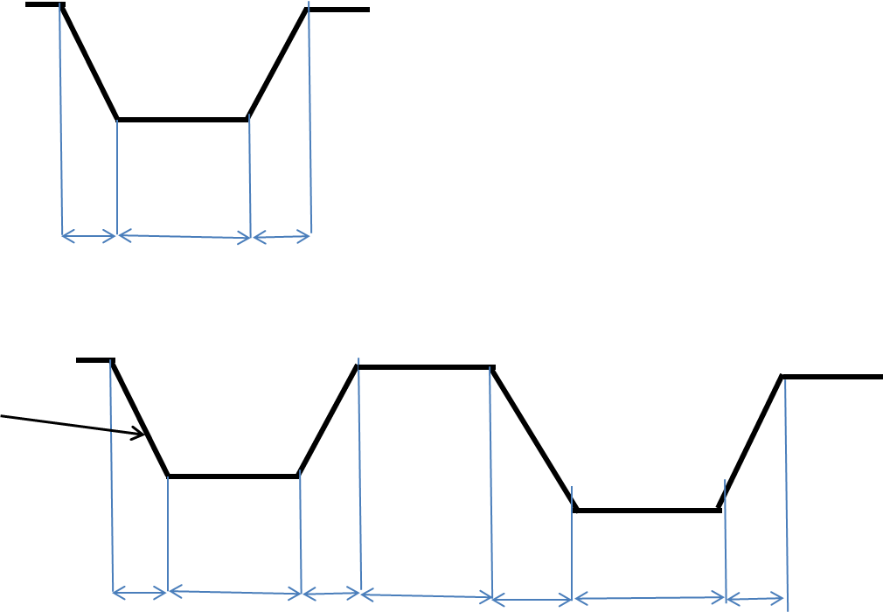

Interval

Dwell

RT

FT

* + - * + **Single Pulse**

Pulse width (in µs)

* + - * + **Double pulse – manual mode**
        + For each pulse:

Pulse width

Dwell time

% of voltage (the voltage that has been calibrated

* + - * + Pulse interval (in µs)
        + **Double pulse – Auto**

In this mode the calculation of the dwell time and the pulse interval will be done automatically depending on the the voltage and pulse width. The following formulae to calculate the above parameters:

*Dwell time = Pulse width - Voltage x % of voltage / slew rate*

Another parameter that will be required by the firmware is the lapse time between the start of the pulse and the trancation point. It will be calculated using the following formula:

*Tdelay* = *Voltage x % of voltage / slew rate*

The interval will be calculated by the following formula:

*Interval = 11.5 – Pulse width*

* 1. **Actuators** 
     1. Material pumps
     2. LED illumination
     3. Waste pump
  2. **Communication setup**



**Appendix A** – warm-up

**Appendix B** – voltage calibration

1. Background

The process (described in the flow chart below) includes the following steps:

* 1. Requested voltage entry
  2. Check if voltage is in range
  3. Calculate potentiometer value for the requested voltage
  4. Calibrate voltage
  5. Save potentiometer value obtained after the calibration in the machine parameters.

1. Parameters

|  |  |
| --- | --- |
| Parameter | value |
| R1 - Model | 12 |
| R2- Model | 1 |
| Vref | 2.5 |

1. Implementation
   1. formulae
      1. Potentiometer- value calculation formula

N = $\frac{\left(R2+1\right)×\left(RV-Vref\right)-R1×Vref}{RV}×256$

***RV*** – requested voltage

* + 1. Max voltage setting (Max_V)

The following steps should be performed in order to find the actual maximum voltage:

* + - 1. Set POT value to 255.
      2. Read the voltage
      3. Read voltage = Vmax_calc
    1. Min voltage setting formula (Min_V)

The following steps should be performed in order to find the actual minimum voltage:

* + - 1. Set POT value to 0.
      2. Read the voltage
      3. Read voltage = Vmin_calc *model, support*

Note:

* The calculated Min_V and Max_V will be displayed in the Requested Voltage field on the Voltage Calibration form. Whenever the form is opened the calculation procedure will be carried out as described above.

**4.2. Calibration process**

The process is described in the following flow chart (the process is identical for both support and model heads, except for the parameters).



